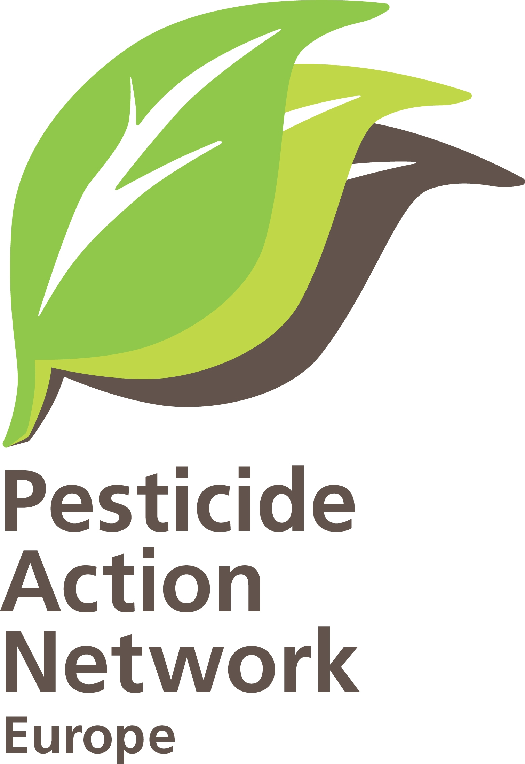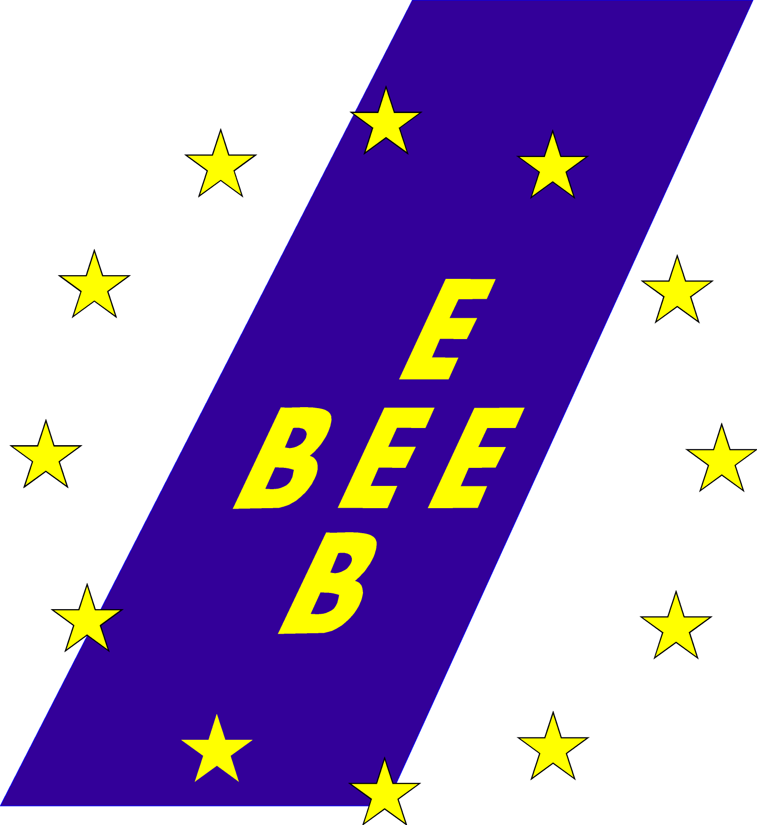
Brussels, 12 January 2009
Re: Vote in plenary on the pesticide package
Dear Member of the European Parliament,
Tomorrow you will be voting on the pesticide package consisting of a Regulation for the Authorisation of Plant Protection Products and a Framework Directive for Sustainable use of Pesticides.
Pesticide Action Network (PAN Europe)* and European Environmental Bureau (EEB) has been campaigning for the last seven years for strict approval rules for pesticides and for an ambitious use reduction strategy. Though we would have liked to see in the final text stricter approval criteria and introduction of clear quantitative reduction targets we understand the importance of reaching a compromise taken into account the many different interests in the field. We therefore urge you to vote for the consolidated compromise text without allowing further derogations on the most hazardous pesticides, calling on your support for amendment 178 as a whole and reject amendments 180 and 181.
The pesticide package will, among others, ban highly toxic chemicals which are carcinogenic, mutagenic, or toxic to reproduction and certain endocrine disrupters unless their effects in practice would be negligible. Also exposure from development neurotoxic and immunitoxic pesticides will be lowered, and their substitution promoted. However, the agreement allows, to our deep regret, a (renewable) derogation for certain active substances if it is considered necessary to combat a serious threat to plant health.
An impact assessment – evaluating the impacts of the agreement with Council and respecting current classifications and scientific evidence - made by the Swedish Chemical Agency, concludes that 22 substances could be affected, equalling around 5% of the active substances available. Amendment 178 will only slightly increase this number.
PAN Europe and EEB urge you to support amendment 178, i.e. the consolidated compromise text, as this text gives some clarity about endocrine disrupting substances.
PAN Europe and EEB urge you to vote against amendment 180, proposing to extend the derogation in Art. 4(7) to PBTs and vPvBs, as alternatives for those substances in question (Pendimethalin) already exist (e.g. aclofinen/ linuron and methabenzthiazuron).
Finally, PAN Europe and EEB urge you to vote against amendment 181, calling on impractical and theoretical impact assessments before implementation. The implementation period is already long with the cut-off criteria only being gradually applied over the next 10 years (a substance approved in 2004 will only be reviewed when the authorisation expires in 2014). The implementation should not be delayed further.
We encourage you to use this once-in a lifetime opportunity to substitute the most hazardous pesticides with safer alternatives for the benefit of the health of European citizens and future generations and the environment.
We remain at your disposal for any further information you may need and we thank you for your kind attention and support.

Sincerely yours
Henriette Christensen Christian Schaible
Policy coordinator Policy Officer for Chemicals
PAN Europe European Environmental Bureau

* PAN Europe is a network of grass roots organisations working to replace the use of hazardous pesticides with ecologically sound alternatives. The European PAN network brings together consumer, public health, and environmental organisations, trades unions, women's groups, and farmer associations from across Europe.

